Session 10 (unit 6): Generic Programming

|  |  |
| --- | --- |
| Roll No. A016 | Name: Varun Khadayate |
| Program: B-Tech (CSBS) | Division: SY |
| Batch: 1 | Date of Submission: 12-10-2020 |

1. **WAP to display the largest among two numbers using function templates.**

**ANS:**

**CODE:** #include<iostream>

using namespace std;

template <class T>

T myMax(T x, T y)

{

return (x > y)? x: y;

}

int main()

{

int x,y;

cout<<"Enter two Numbers::";

cin>>x>>y;

cout<<"\n";

cout<<"The largest number is::"<< myMax<int> (x, y) << endl;

return 0;

}

**OUTPUT:**

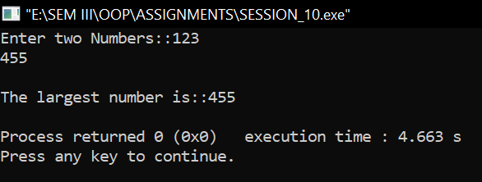

1. **WAP to swap data using function templates.**

**ANS:**

**CODE:** #include<iostream>

#include<stdio.h>

using namespace std;

template <typename T>

void Swap(T &x, T &y)

{

T temp;

temp = x;

x = y;

y = temp;

}

int main()

{

int x,y;

cout<<"Enter the number which you have to perform swap function::";

cin>>x>>y;

cout<<"Before passing data to function template.\n";

cout<<"x = "<<x<<"\ny = "<<y;

Swap<int>(x,y);

cout<<"\n\nAfter passing data to function template.\n";

cout <<"x = "<<x<<"\ny = "<<y;

return 0;

}

**OUTPUT:**

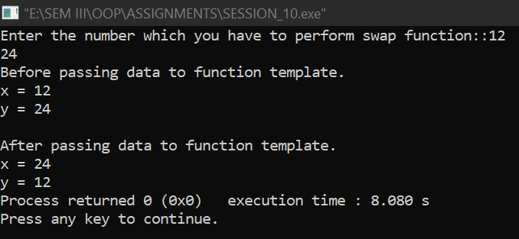

1. **WAP that accepts two different datatypes as arguments to the template function and returns the value.**

**ANS:**

**CODE:** #include<iostream>

using namespace std;

template <class T>

T myMax(T x1, T x2)

{

return (x1 > x2)? x1: x2;

}

int main()

{

int x,y;

float a,b;

cout<<"Enter two integer type Numbers::";

cin>>x>>y;

cout<<"\n";

cout<<"The largest number from the given two integers is::"<< myMax<int> (x, y) << endl;

cout<<"\n\nEnter two floating type Numbers::";

cin>>a>>b;

cout<<"\n";

cout<<"The largest number from the given two integers is::"<< myMax<float> (a, b) << endl;

return 0;

}

**OUTPUT:**

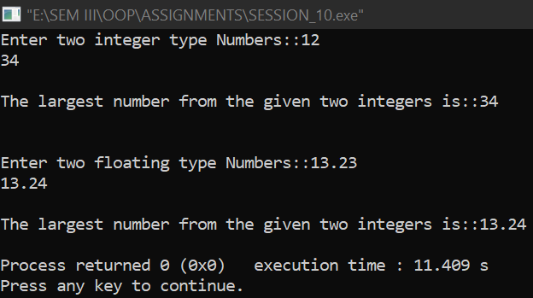

1. **WAP to add, subtract, multiply and divide two numbers using class template.**

**ANS:**

**CODE:** #include<iostream>

using namespace std;

template<class T>

class cal

{

private:

T num1,num2;

public:

cal(T x, T y)

{

num1 = x;

num2 = y;

}

void displayResult()

{

cout << "The Numbers entered are: " << num1 << " and " << num2 << "." << endl;

cout << "Addition of "<<num1<<" and "<<num2<<" is: " << add() << endl;

cout << "Subtraction of "<<num1<<" and "<<num2<<" is: " << subtract() << endl;

cout << "Product of "<<num1<<" and "<<num2<<" is: " << multiply() << endl;

cout << "Division of "<<num1<<" and "<<num2<<" is: " << divide() << endl;

}

T add()

{

return num1 + num2;

}

T subtract()

{

return num1 - num2;

}

T multiply()

{

return num1 * num2;

}

T divide()

{

return num1 / num2;

}

};

int main()

{

int x,y;

cout<<"Enter 2 numbers::";

cin>>x>>y;

cal<int> intCal(x, y);

intCal.displayResult();

return 0;

}

**OUTPUT:**

